Frail Care 24 x 7 x 365
PlumRus West

We offer suitable Basic Care accommodation for mom, dad or a family member who is frail and needs 24-hour basic care. Our rooms are equipped with built-in cupboards and a hand basin; bathrooms are shared between residents.

The services we provide include the following:

- Frail Care
Clean rooms, linen, clothes, hair, teeth, ears, dress/undress, wash/shower and balance diet of 3 meals a day including feeding if needed
- Carer Ratio
Dayshift: 1 carer to 6 residents Night shift: 1 carer to 13 residents
- Ongoing Basic Care and Patrols 24/7
24/7 SIC – Sister in Charge on all shifts
- Wireless Nurse Call and Emergency Button Telephone system for internal convenience
- Security 24/7 with patrols
Electric fence & CCTV Monitoring
- Comprehensive Stimulation & activities Library and many board games,
Protea Coffee Shop 09:00 to 16:00 every day Gym Trim
Bring and Braai
Morning Market once a month
TV, DVD’s, Netflix, Showmax & YouTube in Lounges
Pool Table, Table Tennis, Darts & Bingo
Social Evenings, beautiful garden and walkways
- 10:30 Daily Stimulation in all Lounges
- 14:00 every 2nd Thursday Stimulation in Sugarbush Lounge
- Spiritual Program Bible Studies Prayer Meetings
Sunday Services (English & Afrikaans)
One-Hour-For-Jesus on Fridays
- Transport at your own cost from R 12 per km Shopping Trips twice a week
Doctor Visits
Outings & ad hoc transport when needed
- PlumRus DSTV Bouquet for R590 per month
- Communication System Fixed line
Telephone installed; line activated for external calls at a cost of R165. Costs per call for your own account.
Wi-Fi for R490 per month
- Medication Administration – included
- Nappy Administration – included
- One-on-One Carer options available at your own cost when needed for Specialized Basic Care
 | TYPE OF  Accommodation | Maximum rent Per Month | Once off Maintenance fee
 | Single Room Spacious Room | R16, 750  R18 900 / R21 930 | R12,500 R14,000

Rental Flats PlumRus East

We offer suitable accommodation for mom, dad, or a family member. Residents will have the privacy of their own Bachelor or One Bedroom Flat including Bathroom and Kitchenette.

The services we provide include the following:

- One main meal a day – “Lunch”
- Weekly laundry service
- Weekly domestic service
- Wireless Nurse Call and Emergency Button Telephone system for internal convenience
- Security 24/7 with patrols
Electric fence & CCTV Monitoring
- Comprehensive Stimulation & activities Library and many board games
Protea Coffee Shop 09:00 to 16:00 every day
Gym Trim Bring and Braai
Morning Market once a month
TV, DVD’s, Netflix, Showmax & YouTube in Lounges Pool Table, Table Tennis, Darts & Bingo Social Evenings, beautiful garden and walkways
- Parking Bay – if needed and available
- Spiritual Program Bible Studies Prayer Meetings Sunday Services (English & Afrikaans)
- One-Hour-For-Jesus on Fridays
- Transport at your own cost from R12 per km Shopping Trips twice a week
Doctor Visits
Outings & ad hoc transport when needed
- PlumRus DSTV Bouquet for R590 per month
- Communication System Fixed line
Telephone installed; line activated for external calls at a cost of R165. Costs per call for your own account.
Wi-Fi for R490 per month
- Medication Administration – R1,125 per month - Available if needed
- Nappy Administration – Available if needed
- One-on-One Carer options available at your own cost when needed for Assisted Care & tailor-made Basic Care packages
- Assisted Living/Full Frail Care services (Clean rooms, linen, clothes, hair, teeth, ears, dress/undress, wash/shower and balance diet of 3 meals a day including feeding if needed. Medication and Nappy Administration included.) in the privacy of your flat – at additional R6,200 per month for rental or life right flats in our East building
 | TYPE OF  Accommodation  Bachelor Flat | Maximum rent  R16 750 / R20 750 | Once off Maintenance fee R19,950
 | One bedroom Flat | R18 600 / R22 600 | R22,000

Independent Living Loan Agreement Flats
PlumRus North, Mountain View & East

We offer suitable accommodation for the independent spirit, who still does their own things in their own time but needs to be in a safe, happy, homely environment with an abundance of friends and where basic care is available when or if needed.

The services we provide include the following:

- One main meal a day - “Lunch”
- Weekly laundry service
- Weekly domestic service
- Wireless Nurse Call and Emergency Button Telephone system for internal convenience
- Security 24/7 with patrols
Electric fence & CCTV Monitoring
- Comprehensive Stimulation & activities Library and many board games
Protea Coffee Shop 09:00 to 16:00 every day
Gym Trim Bring and Braai
Morning Market once a month
TV, DVD’s, Netflix, Showmax & YouTube in Lounges Pool Table, Table Tennis, Darts & Bingo Social Evenings, beautiful garden and walkways
- Garage or Parking Bay – if needed and available
- Spiritual Program Bible Studies Prayer Meetings
Sunday Services (English & Afrikaans)
One-Hour-For-Jesus on Fridays
- Transport at your own cost from R12 per km Shopping Trips – twice a week
Doctor Visits
Outings & ad hoc transport when needed
- PlumRus DSTV Bouquet for R590 per month
- Communication System Fixed line
Telephone installed; line activated for external calls at a cost of R165. Costs per call for your own account. Wi-Fi for R490 per month
- Medication Administration for R1,125 pm if needed
- Nappy Administration available if needed
- One-on-One Carer options available at your own cost when
needed for Assisted Care & tailor-made Basic Care packages
 | TYPE OF  Accommodation  One bedroom two/three bedrooms | Maximum rent 1 Person/2 People  R10 550/ R16 100  R10 550/ R16 100 | Once off Maintenance fee  R22,000 R26,000

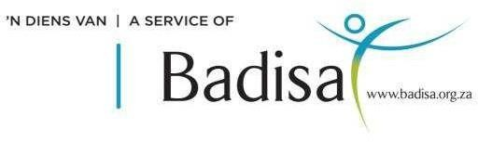
1 Birmingham Road
Plumstead 7800
021 761 2323
info@plumrus.co.za

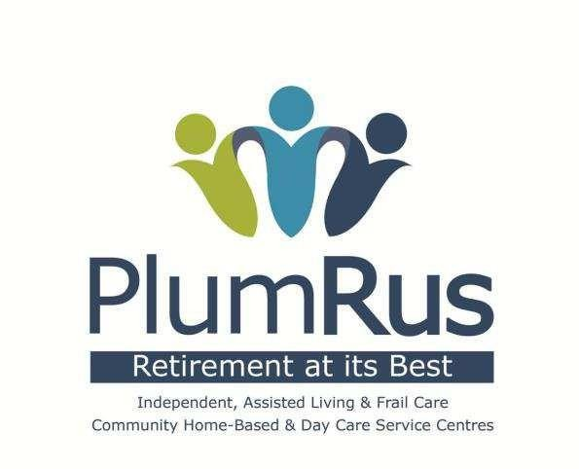
PlumRus strives to create a safe, happy, homely residential facility and service centres in which residents, members and staff can participate in the decision making, upkeep and management thereof. We wish to utilize the infrastructure and facilities as an Innovation hub for services to older persons in our community.
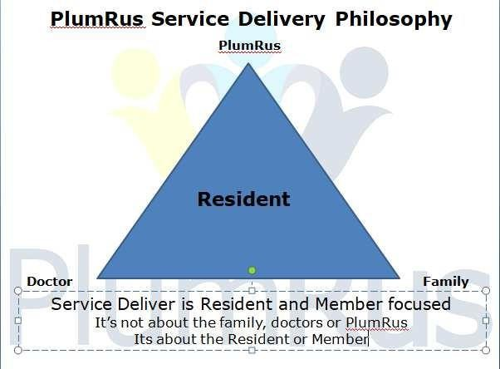


18 Birmingham Road
Plumstead 7800
021 761 2323
info@plumrus.co.za
website: www.plumrus.co.za

